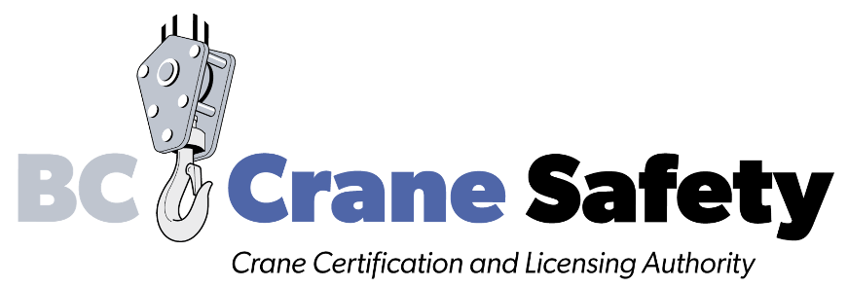

Application Form

Compliance Verification for
Crane Mechanic (Limited Scope, Non-commercial Lift)
A BC Crane Mechanic (Limited Scope, Non-commercial Lift) designation allows the mechanic to operate a crane in the role of mechanic on behalf of an employer. The designation is restricted to that role. No commercial lifts are allowed. The employer is responsible for all lifts.
Please review the training and supervision requirements and the responsibilities of employers and mechanics published on the BC Crane Safety website.
Instructions

- Print this document.

- Complete the form including all signatures.
- Print clearly.
- All fields are required. Processing will be delayed if information is missing.

- Provide a photo of the operator for the digital card we will issue.
- Email a digital photo (min. 300 dpi / medium resolution) to info@bccranesafety.ca
- Include the head and shoulders.
- Take the picture in front of a plain, light-coloured background.
- No hats or sunglasses to be worn.

- For instructions on where to send your application, see the last page of this document.

Mechanic Information please print clearly

Legal First Name Legal Middle Name Legal Last Name

Address Apt / Suite

City Province Postal Code

( ) - ( ) - ( ) -
Phone Cell Fax

dd /mm /yyyy
Email Date of Birth

BC Crane Safety ID Number (Mandatory)

Employer Information please print clearly

Company Name WorkSafeBC Account Number

Address Suite

City Province Postal Code

Contact Name Email

( ) - ( ) - ( ) -
Phone Cell Fax

Agreement
Crane Mechanic (Limited Scope, Non-commercial Lift)

In the event of an incident, WorkSafeBC will request evidence that the mechanic has been trained to operate the crane classification involved.

The Crane Mechanic (Limited Scope, Non-commercial Lift) compliance statement is not transferable between employers. If the crane mechanic changes employers, this compliance statement and the operator’s mechanic designation is no longer valid.

Crane Mechanic | Employer
I have read and understood all the conditions in this application. I agree to operate only crane(s) within the classification I have been trained on and signed off on by the employer named on this application.  I understand that no critical lifts or commercial lifts are permitted. | I have read and understood all the conditions in this application and I agree that the crane mechanic has received adequate training and will operate only crane(s) within the classification as verified and signed off on by me, the employer.  I understand that no critical lifts or commercial lifts are permitted.
______________________________  Crane Mechanic: Legal First & Last Name  Please print clearly | ______________________________  Employer: Legal First & Last Name  Please print clearly
______________________________  Crane Mechanic: Signature | ______________________________  Employer: Signature
______________________________  Date | ______________________________  Date

Send the application to BC Crane Safety

Remember to date and sign the form.

Scan and email the application to info@bccranesafety.ca. Please attach a digital photo if you haven’t already sent it to us.

Or send the application by mail or courier to:
BC Crane Safety
PO Box 42066
RPO Guildford
Surrey, BC V3R 1S5

